Screen Shots of Online Classes
GOVT. JAMUNA PRASAD VERMA PG ARTS AND COMMERCE COLLEGE BILASPUR (CHHATTISGARH)

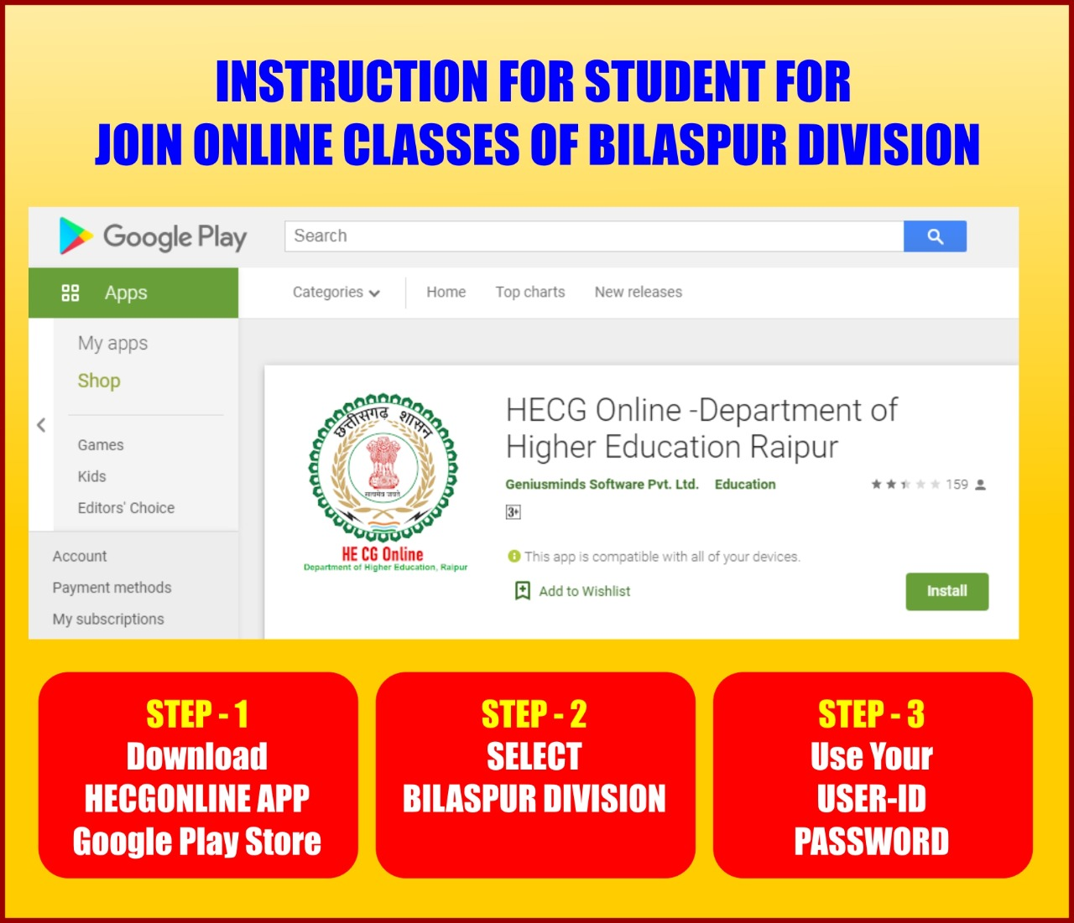
Hecgonline.in : Online Class

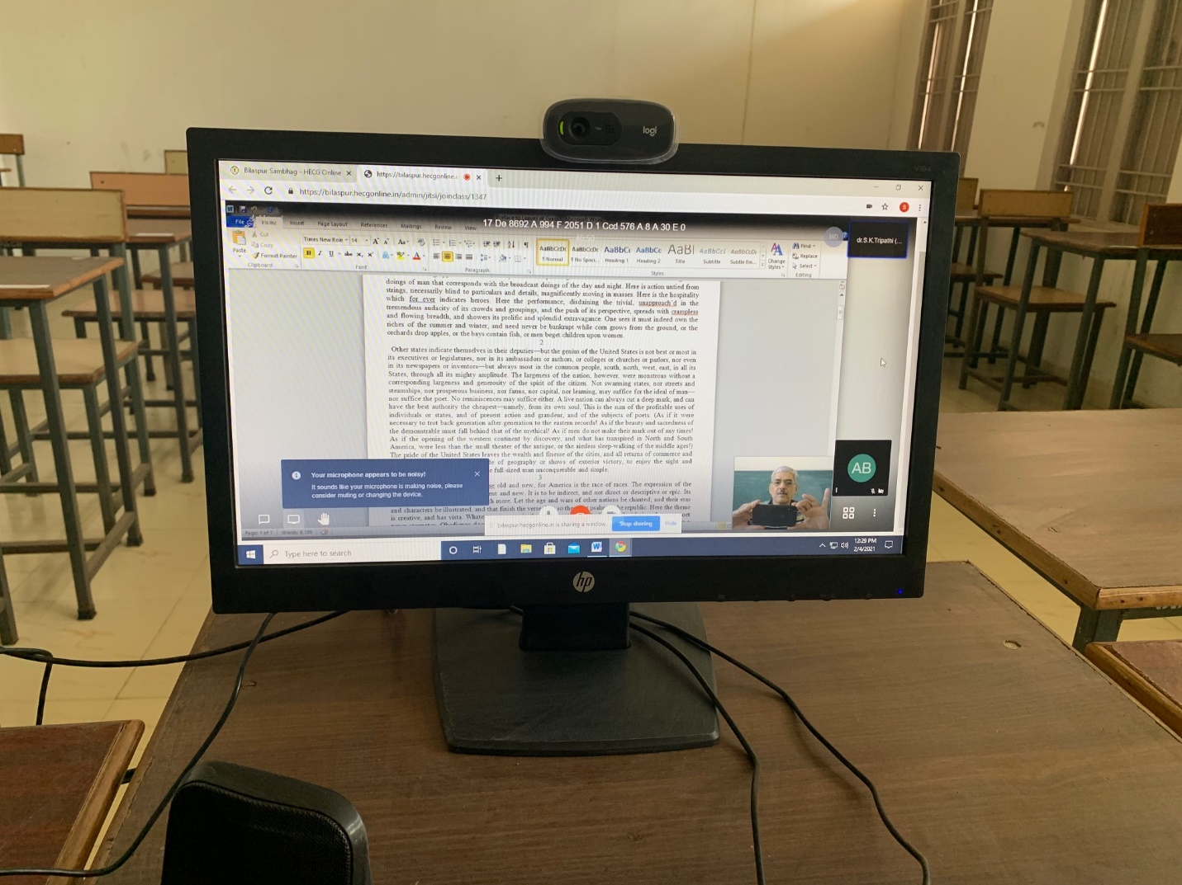
Hecgonline.in : Online Class

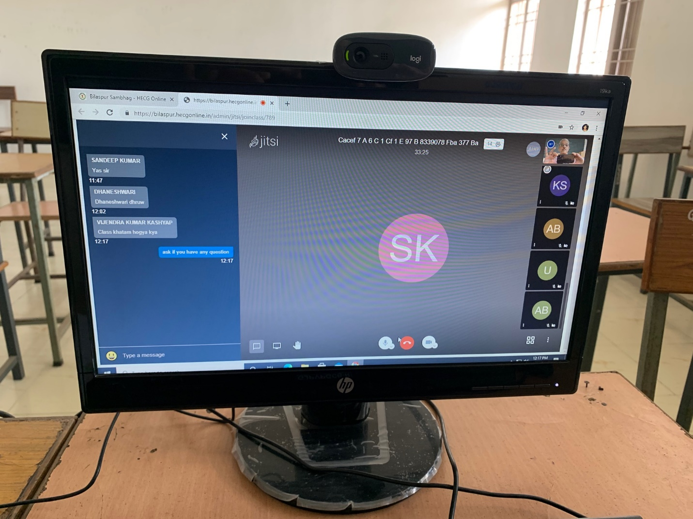
Hecgonline.in : Online Class

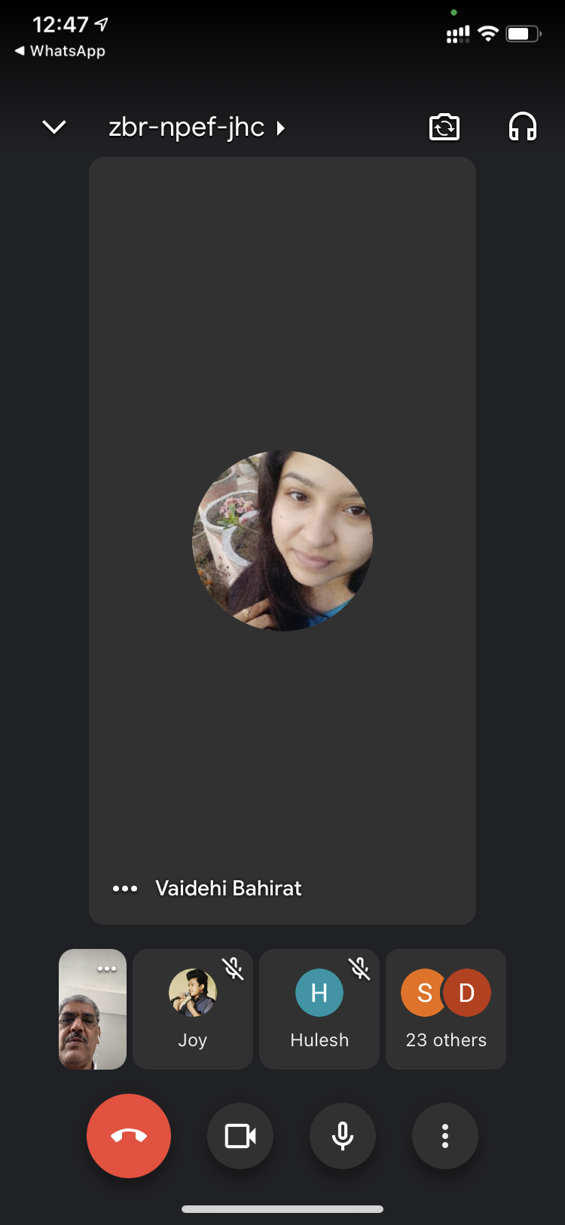

Sharing Google Meet via WhatsApp for Online Class

Google Meet: Online Class

